**Project Development Phase**

**Sprint-2**

|  |  |
| --- | --- |
| Date | 6th November 2022 |
| Team ID | PNT2022TMID02193 |
| Project Name | VirtualEye – Life Guard for Swimming Pools to Detect Active Drowning |
| Maximum Marks | 4 Marks |

**Dataset Collection**

~200 sample images of potential drowning subjects were used to train the YOLO model

*more the number of sample images, more the accuracy!*

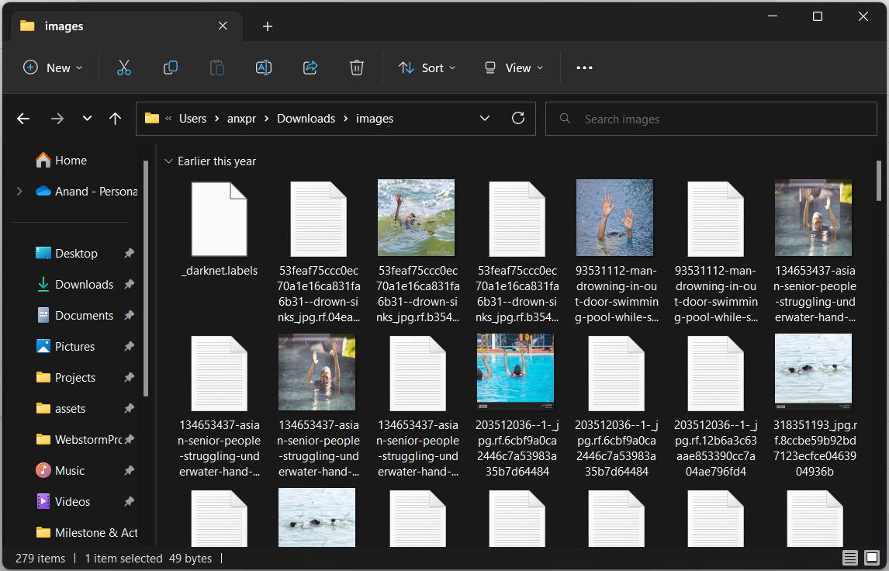

**Pre-Processing Data**

**labelimg** library was used to select over sections where there were potential drowning subjects from sample images to generate labels for classification, this would later be used to train the YOLO model.

